**C) No. of meetings attended by each member.**

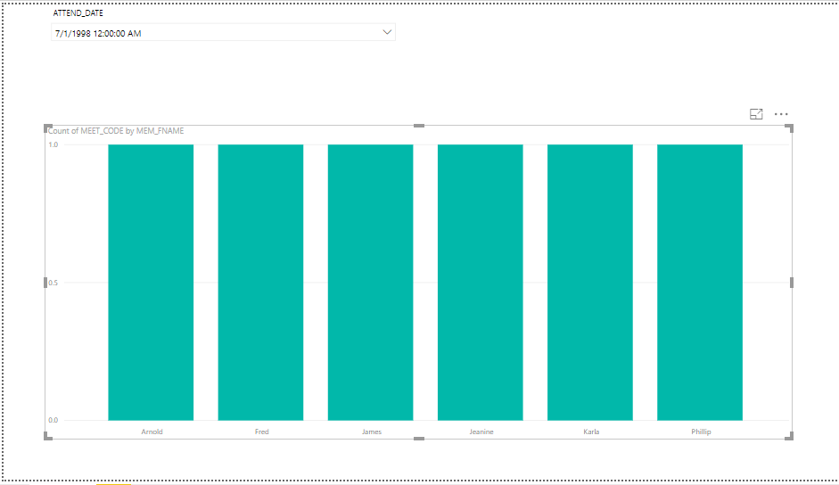

DATE: 7/1/1998

This bar chart shows that out of thirteen members, only Arnold, Fred, James, Jeanine, Karla and Philips attended the first meeting.

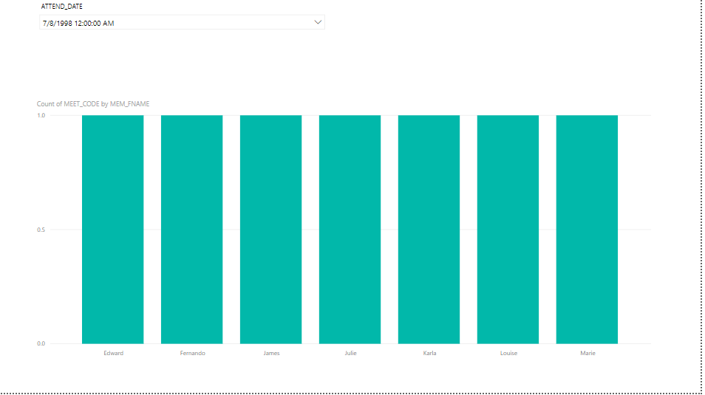

DATE: 7/8/1998

The second meeting was attended by Edward, Fernando, James, Julie, Karla, Louise and Marie.

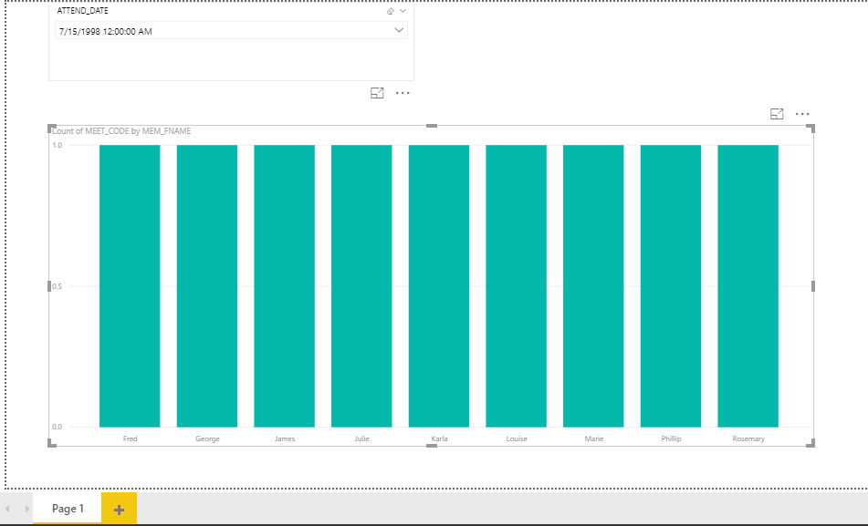

DATE: 7/15/1998

Out of thirteen members, nine members attended this meeting. There names are Fred, George, James, Julie, Karla, Louise, Marie, Philip, and Rosemary.

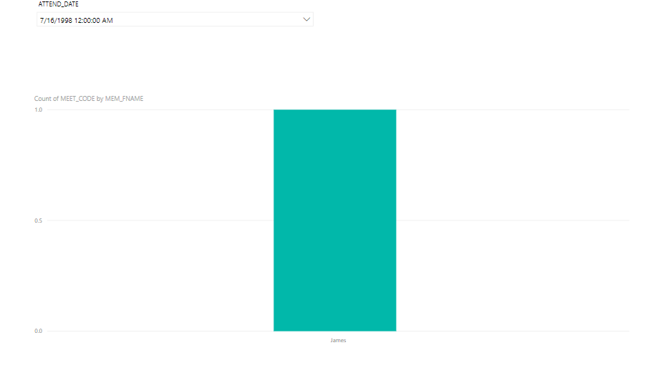

DATE: 7/16/1998

The last meeting is only attended by James.

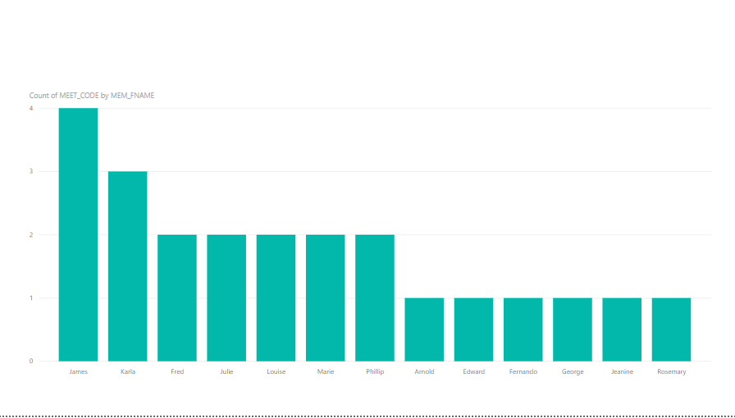

This chart displays that the highest number of meetings that is 4 is attended by James. Arnold, Edward, Fernando, George, Jeanine and Rosemary attended only 1 meeting which is the lowest number of meetings attended by the members. The second highest number of meeting is 3 and it is attended by Karla. The remaining five people, Fred, Julie, Louise, Marie and Philip attended 2 meetings only.